Toll Free Order Line 1 (800) 344-7677
(813) 835-7900
4344 S. Manhattan Ave.
Tampa, FL 33611
Home | Shopping Cart | Contact | Return Policy
Directions | Store Hours

Search:

Home / Massage Chairs / Desktoppers / Stronglite Standard Table & Standard Chair Package

Stronglite Standard Table & Standard Chair Package | MSRP: $418.00  Your Cost: $369.00  Your Savings: $49.00!  Purchase options listed below

Product Description
TablePackage Includes:
• Standard Portable Massage Table
• Deluxe Adjustable Headrest w/ cushion
• Standard carry case
Chair Package Includes:
• Standard Massage Chair
• Deluxe Adjustable Headrest w/ Cushion
• Chair Carry Case
Table Key Features:
• Dimensions: 30" x 73"
• Height adjustable from 23" to 33"
• Weight 32 lbs!
• Quality Birch Hardwood Frame & Birch Plywood Table Top
• Patented Cradle Lock Cable Support
• Full length piano hinge
• 100% PU upholstery in Agate and Black
• 2 1/2" Foam System
• Warranty: Limited Lifetime on Frame, 3 years on Foam and Vinyl
• 400 lb. drop tested
Chair Key Features:
• Aircraft aluminum frame
• Two-layer 2" cushioning system
• 100% PU upholstery in Agate and Black color choices
• Maximum working weight: 300 lbs
• Seat height has 3 adjustment settings
• Arm rest has 3 adjustment settings
• Slide Chest height adjustment
• Great beginner chair
• 2 year limited warranty

*Entire Package ships for only $30.00*
Sale price on this item is for website orders only.
Call for in store price and availability.

Price: $369.00
Options
Choose Chair Color:
Choose Table Color:
Quantity:
Notes:
Type a Message to Customer Service here.

Copyright © 2000-2003, Sunset Park Massage Supplies. All rights reserved.
web site provided by WebTent Networking, Inc., webmaster@webtent.com

Waffle Weave Robe #W-100 | Your Cost: $29.95  Purchase options listed below

Waffle weave robe is ONE SIZE FITS ALMOST ALL.
MADE OF 67% COTTON, 33 % POLY.
Available in white only

Price: $29.95
Quantity:
Notes:
Type a Message to Customer Service here.

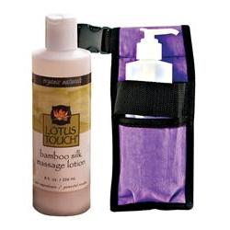
Enlarge / Alternate Images

"Holsters Of Silk" Package
# 219 0238
Reviews

Rate this product

Choose COLOR for Hold All Holster

Selection: NAVY
Clear

Price: $22.96$11.99
Qty

Kit Includes:
Hold All Holster
Bottle Pump 8 Oz
Plastic Bottle Only 8 Oz
Lotus Touch Bamboo Silk Massage Lotion 8 Oz

- Description
- Recently Viewed

"Holsters Of Silk" Package
Free Lotus Touch Organic Naturals Bamboo Silk Massage Lotion, 8oz with the purchase of our Hold All Holster. An $8.99 value.
Package includes:
- Hold All Holster - This holster can hold a bottle or a jar (both sold separately). Designed to be worn when giving a massage, it conveniently holds massage products at waist height. Available in several holster colors. 50" Long. Compatible with the Holster Belt Extension, item 245 0244
- FREE! Bamboo Silk Massage Lotion 8 oz - Organic Naturals Bamboo Silk Massage Lotion is eco-friendly and features a powerful blend of renewable bamboo silk powder, green tea extract and organic aloe vera juice. Fast absorbing lotion is great for facial massage, reflexology, therapeutic massage. Fragrance free.
- FREE! 8 oz. Plastic Bottle
- FREE! Pump for 8 oz. Bottle

Therapro Aromatherapy Massage Kit
# 246 0270
Reviews

Rate this product

Price: $36.95$29.99
Qty

Kit Includes:
Therapro Ess Oil 100% Lavender 10 Ml
Therapro Ess Oil Peppermint 10 Ml
Therapro Essential Oil Fusion Stress Relief 10Ml
Therapro Essential Oil Fusion Respiration 10Ml
Therapro Golden Jojoba Massage Oil 8 Oz

- Description
- Recently Viewed

TheraPro Aromatherapy Massage Kit
Save on aromatherapy massage favorites from TheraPro with this essential aromatherapy kit.
Kit Includes:
(1) Lavender Single Note Oil 10 ml
(1) Peppermint Single Note Oil 10 ml
(1) Stress Relief Fusion Oil 10 ml
(1) Respiration Fusion Oil 10 ml
(1) 8 oz TheraPro Jojoba Massage Oil - Ingredients Simmondsia Chinensis (Jojoba) Oil
Use caution when laundering linens that have been exposed to oils. Oil products are potentially combustible when exposed to heat in the dryer. Consult dryer manufacturer’s guidelines for drying linens that have been exposed to oils.
Top of Form
Enlarge / Alternate Images

Mhp Massage Oil Set Of 4
# 224 0265
Reviews

Rate this product

In Stock. Will ship in 24-48 hours.
Price: $35.99
Qty

- Description
- Recently Viewed

Massage Oil Variety 4 Pack
These non-allergenic, superior-grade massage oils are a blend of 8 different natural oils and 3 vitamins. They nourish the skin and provide the perfect glide desired by massage therapists.
These contaminant-free oils are water dispersible for ease of washing linens, and are vegetable based. No petroleum additives, alcohol, or animal ingredients are used, and they did not undergo any animal testing.
The Exotic Blend Aromatherapy Oil takes your senses on an exciting journey. Soothing Blend Aromatherapy Oil provides a comfort and stress-relieving feeling all over while promoting a deep sense of peace. Refreshing Blend Aromatherapy Oil awakens your spirits, rejuvenates your body and gives you a sense of renewed energy. Our Unscented Oil provides superior lubrication and smooth glide.
Specifications:
- Provides superior lubrication and smooth glide required for massage
- Non-allergenic, contaminant-free, fully absorbent and nourishing for the skin
- Combines 8 different natural oils and Vitamins A, D, and E
- Water dispersible for ease of washing linens
- No alcohol or petroleum products used
- No animal ingredients or testing used
- Each bottle contains a blend of all natural ingredients and is 100% pure
- The four-pack includes one 8 oz. bottle of each type
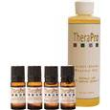

Therapro Aromatherapy Massage Kit
$29.99
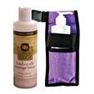

"Holsters Of Silk" Package
$11.99
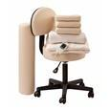

Basic Room Starter Package
$134.99
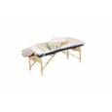

NRG Basic Table Package 1 - Standard
$269.99

Related Items
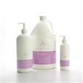
Amber Lavender Aphrodisia Massage Oil
$7.99 - $48.99
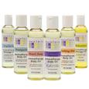
Aura Cacia Aromatherapy Body Oils 4 Oz
$7.99
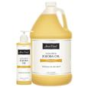
Bon Vital Golden Jojoba Oil
$8.06 - $76.46
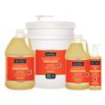
Bon Vital Muscle Therapy Oil
$13.46 - $382.31

Sign up for email news and sales announcements:

- Easy Ordering
  - Catalog Quick Order
  - Request a Catalog
  - Store Directory
  - Our Policies
  - Habla Espanol
- Customer Service
  - Help Desk
  - Shipping & Delivery
  - Returns & Exchanges
  - International Orders
  - Contact Us
  - My Account
  - FAQ
- Services
  - Our Guarantee
  - Wish List
  - Privacy Policy
  - Website Help
- Our Company
  - About Us
  - Email Newsletter
  - New Vendor Submission
  - Green Aware
  - Corporate Sales
- Resources
  - Education
  - Videos
  - Self-Care
  - Blog

©2011 Massage Warehouse - Massage Tables, a division of Scrip, Inc
- Twitter
- FaceBook

Bottom of Form

Skip to Main Content
Top of Form
Massage Equipment, Supplies and Tables
Sign up for Emails | Catalog Request Login | Call 1.800.910.9955
SHOPPING CART 0 Items Send Feedback | Blog | Track Your Order
Shop By:
- Brands

- Sale

- Massage Products
  - Cleaning Supplies
  - Hot & Cold Therapy
  - Linens & Table Coverings
  - Massage Tools
  - Table Accessories

- Oils, Creams & Lotions
  - Bottles & Accessories
  - Massage Creams
  - Massage Gels
  - Massage Kits
  - Massage Lotions
  - Massage Oils
  - Salt & Sugar Scrubs
  - Topical Analgesics
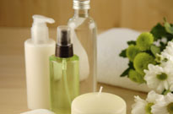

- Equipment
  - Chiropractic
  - Esthetic Equipment
  - Massage Chairs
  - Portable Tables
  - Stationary Tables
  - Stools
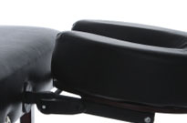

- Aromatherapy
  - Bath
  - Candles
  - Carrier Oils
  - Cylinder Works
  - Diffusers & Accessories
  - Essential Oils & Blends
  - Mists & Sprays

- Treatment Supplies
  - Ayurvedic, Healing & Energy
  - Bamboo Massage
  - Body Care
  - Cold Stone Massage
  - Collagen
  - Herbs & Wraps
  - Hot Shells
  - Hot Stone Massage
  - Masques
  - Parafango
  - Paraffin
  - Scrubs
  - Tanning
  - Thai Massage
  - Yoga & Fitness

- Esthetic Supplies
  - Apparel
  - Bowls & Bottles
  - Brushes
  - Cotton Supplies
  - Disinfectants & Sanitizers
  - Loofahs & Sponges
  - Manicure-Pedicure
  - Protective Supplies
  - Salon
  - Scissors, Extractors & Tweezers
  - Sterilizers
  - Waxing

- Media
  - Books
  - Continuing Education
  - DVD's/Videos
  - Learning Aids
  - Marketing & Business
  - Music

home . shop by department . equipment . massage chairs . portable massage . melody portable massage chair
Email Print

Go Back Portable Massage
Previous Next

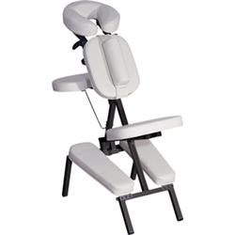
Enlarge / Alternate Images

Melody Portable Massage Chair
# 218 0089
Reviews

Rate this product

COLOR:

Selection:

Price: $199.00
Qty

- Description
- Recently Viewed

Melody Portable Massage Chair
The Melody Massage Chair is ergonomically designed to offer maximum comfort to both client and practitioner. Sets up in seconds and folds for easy transport and storage. The flexibility of arm height and angle adjustments, an adjustable chest pad, removable sternum pad, adjustable headrest and seat height and angle adjustments help match your working height and fits your client perfectly.
Specifications:
Weight: | 18 lbs
Working Weight: | 300 lbs
UL/CE Certified: | CE
Free Shipping | NO
Warranty: | 2 year limited warranty

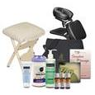

Professional Caregiver Package
$216.99
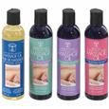

Mhp Massage Oil Set Of 4
$35.99

Therapro Aromatherapy Massage Kit
$29.99

"Holsters Of Silk" Package
$11.99

Related Items
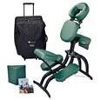
Earthlite Avila II Massage Chair Package
$399.00
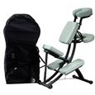
Oakworks Portal Pro 3 Massage Chair Package
$399.99 - $470.99
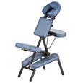
Stronglite Standard Massage Chair Package
$159.99
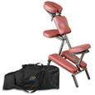
NRG Grasshopper Massage Chair
$179.99

Sign up for email news and sales announcements:

- Easy Ordering
  - Catalog Quick Order
  - Request a Catalog
  - Store Directory
  - Our Policies
  - Habla Espanol
- Customer Service
  - Help Desk
  - Shipping & Delivery
  - Returns & Exchanges
  - International Orders
  - Contact Us
  - My Account
  - FAQ
- Services
  - Our Guarantee
  - Wish List
  - Privacy Policy
  - Website Help
- Our Company
  - About Us
  - Email Newsletter
  - New Vendor Submission
  - Green Aware
  - Corporate Sales
- Resources
  - Education
  - Videos
  - Self-Care
  - Blog

©2011 Massage Warehouse - Massage Tables, a division of Scrip, Inc
- Twitter
- FaceBook

Bottom of Form

Zoom zoom reset
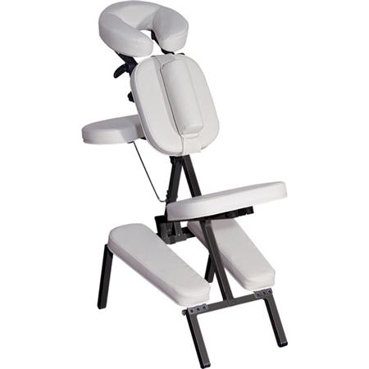
Alternative Views
- There are no alternate images available for this product.

Skip to Main Content
Top of Form
Massage Equipment, Supplies and Tables
Sign up for Emails | Catalog Request Login | Call 1.800.910.9955
SHOPPING CART 0 Items Send Feedback | Blog | Track Your Order
Shop By:
- Brands

- Sale

- Massage Products
  - Cleaning Supplies
  - Hot & Cold Therapy
  - Linens & Table Coverings
  - Massage Tools
  - Table Accessories

- Oils, Creams & Lotions
  - Bottles & Accessories
  - Massage Creams
  - Massage Gels
  - Massage Kits
  - Massage Lotions
  - Massage Oils
  - Salt & Sugar Scrubs
  - Topical Analgesics

- Equipment
  - Chiropractic
  - Esthetic Equipment
  - Massage Chairs
  - Portable Tables
  - Stationary Tables
  - Stools

- Aromatherapy
  - Bath
  - Candles
  - Carrier Oils
  - Cylinder Works
  - Diffusers & Accessories
  - Essential Oils & Blends
  - Mists & Sprays

- Treatment Supplies
  - Ayurvedic, Healing & Energy
  - Bamboo Massage
  - Body Care
  - Cold Stone Massage
  - Collagen
  - Herbs & Wraps
  - Hot Shells
  - Hot Stone Massage
  - Masques
  - Parafango
  - Paraffin
  - Scrubs
  - Tanning
  - Thai Massage
  - Yoga & Fitness

- Esthetic Supplies
  - Apparel
  - Bowls & Bottles
  - Brushes
  - Cotton Supplies
  - Disinfectants & Sanitizers
  - Loofahs & Sponges
  - Manicure-Pedicure
  - Protective Supplies
  - Salon
  - Scissors, Extractors & Tweezers
  - Sterilizers
  - Waxing

- Media
  - Books
  - Continuing Education
  - DVD's/Videos
  - Learning Aids
  - Marketing & Business
  - Music

home . shop by department . aromatherapy . candles . flameless frosted 5" glass votive holders
Email Print

Go Back Candles
Previous Next

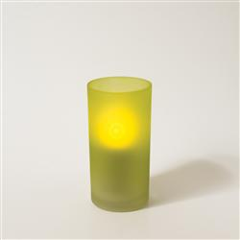
Enlarge / Alternate Images

Flameless Frosted 5" Glass Votive Holders
# 253 0070
Reviews

Rate this product

COLOR:

Selection:

Price: $3.29
Qty

- Description
- Customer Reviews
- Recently Viewed

Frosted Glass Flameless Tealight & Votive Holders
Accessorize your tealights and votives with our decorative holders. Available in Blue, White, Red and Green.
Dimensions: 5” H
Read all 1 reviews | Rate this product
< Previous | Page 1 of 1 | Next >

"
4

How do they work how long does stay light looking
By flameless frosted 5" glass voltive candles November 22, 2010

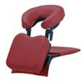

Oakworks Desktop Portal
$195.00
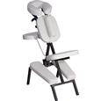

Melody Portable Massage Chair
$199.00

Professional Caregiver Package
$216.99

Mhp Massage Oil Set Of 4
$35.99

Related Items
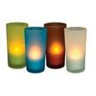
Flameless Frosted 5" Glass Votive Holders
$3.29

Sign up for email news and sales announcements:

- Easy Ordering
  - Catalog Quick Order
  - Request a Catalog
  - Store Directory
  - Our Policies
  - Habla Espanol
- Customer Service
  - Help Desk
  - Shipping & Delivery
  - Returns & Exchanges
  - International Orders
  - Contact Us
  - My Account
  - FAQ
- Services
  - Our Guarantee
  - Wish List
  - Privacy Policy
  - Website Help
- Our Company
  - About Us
  - Email Newsletter
  - New Vendor Submission
  - Green Aware
  - Corporate Sales
- Resources
  - Education
  - Videos
  - Self-Care
  - Blog

©2011 Massage Warehouse - Massage Tables, a division of Scrip, Inc
- Twitter
- FaceBook

Bottom of Form

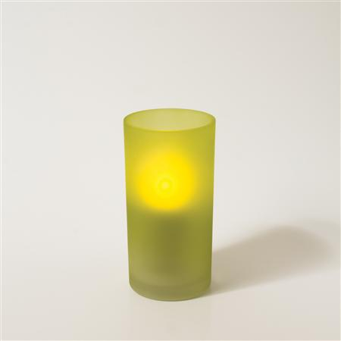
Alternative Views
- There are no alternate images available for this product.

Stone Massage 50Pc Set
# 281 0192
Reviews

Rate this product

In Stock. Will ship in 24-48 hours.
Price: $84.95
Qty

- Description
- Recently Viewed

Stone Massage Set w/Manual & DVD 50 Piece
The perfect natural stone set to work on all parts of the body.
This 50pc set includes:
- 8 Large Stones
- 18 Medium Stones
- 14 Small Stones
- 8 Toe Stones
- Educational Manual
- DVD

Sears

Kmart

myGofer

Craftsman

Kenmore

PartsDirect

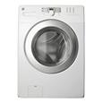
Kenmore High Efficiency 4.0 cu. ft. Capacity Front Load Washer
Reg Price:
Savings: $210.00
$489.99

